SOUTHEAST ENTERPRISES: 2022 ANNUAL REPORT
Submitted by Lauren Hall, CEO
(Note: all data can be verified by payroll/time edit documents, reports, formal feedback surveys)
Setting the Stage: Financial Summary (unaudited)
- Operating Expenses $2,180,513
- Total Income $2,361,986
- Net Income $ 182,451

POPULATION STATISTICS OF INDIVIDUALS SERVED: 117 Currently
(134 indiv. during the year)

- Gender and Ethnicity
Gender # | Percentage | Ethnicity # | Percentage
Female 49 | 42% | African Am. 18 | 37%
 |  | Caucasian 31 | 63%
Male 68 | 58% | African Am. 29 | 43%
 |  | Caucasian 37 | 54%
 |  | Hispanic 2 | 3%

- Disability
Disability | # of Individuals | Percentage
I/DD | 95 | 81%
Autism | 17 | 15%
Vision Impaired/Seizure | 1 | 1%
Mental Retardation* | 4 | 3%
*not SE’s classification

- Modes of Transportation
Mode | # of Individuals | Percentage
Eitas | 64 | 55%
ISL Staff | 39 | 33%
Public (taxi, KCRide) | 12 | 10%
Family | 4 | 1.5%
Self | 1 | 0.05%

- Annual Attendance Rate 100% 2 individuals
95 - 99% 45 “ “
85 – 94% 46 “ “
75 – 84% 19 “ “
50 – 74% 8 “ “
Below 50% 2 “ “

- Transitional Activity – Of the 17 individuals who transitioned from Southeast Enterprises, 5 individuals were prepared for competitive community employment (29%). Another 5 individuals resigned (29%), 2 people retired, 2 moved out of the area, and 2 left for medical reasons. One individual had to be terminated because of unsafe behavior. During the year, however, 11 new individuals entered our program.
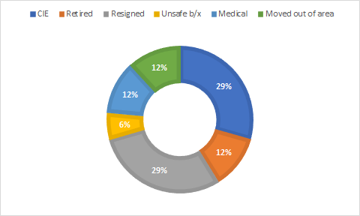

Associate Wages/taxes/PTO paid out to 134 eligible persons throughout the year
- $817,183

- SE (Southeast Enterprises) approved a total of 10 paid holidays to respond to a more diverse and inclusive culture
  - New Year’s Day Dr. Martin Luther King, Jr. Day (new)
  - Memorial Day Juneteenth, Emancipation Day (new)
  - July 4th Independence Labor Day
  - Thanksgiving Day and Christmas Eve and Christmas Day (2)
Day after (2)

Staff Wages/taxes/PTO (17 service and support professionals)
- $711,819

Revenue Sources
- Secured business contracts $1,091,809 (46%)
- Associates on the Move $ 34,050 (1.5%)
Program
- DESE $ 664,945 (28%)
- Eitas $ 581,658 (24%)
- Fundraising $ 13,473 (0.5%)

WIOA – Career Counseling
Conducted twice a year with 100% participation

MISSOURI QUALITY OUTCOME #1: Participating in Meaningful Daily Activities of Choice
(Work/Job Skills/Meaningful Employment/Social Enrichment)

Client Services for 117 active individuals
- Value of meaningful jobs secured: $1,130,848
- Total wages and fringe benefits for eligible individuals: $817,183
  - Quarterly Average Hourly Rate (AHR) shop-wide
    - Q1 = $5.07
    - Q2 = $4.42
    - Q3 = $4.88
    - Q4 = $5.34
        - Annual Calendar Year Average Hourly Rate @ $4.93
        - Average Hourly Rate for month of December @ $6.19

  - 9 Individuals earning Missouri minimum wage ($12.00) or higher (8%)
  - 24 Individuals earning Federal minimum wage ($7.25) or higher (21%)
    - Both categories above have a productivity rate of 69% - 189%, or are making a guaranteed hourly rate based on their productivity for that skill (e.g. material handler or lead worker)
  - 6 Individuals earning $6.00 - $7.24 (5%)
    - Have a current productivity rate of 57% - 68%
  - 45 Individuals earning $3.00 - $5.99 (38%)
    - Have a productivity rate of 27% - 56%
  - 33 Individuals earning below $3.00 (28%)
    - Have a productivity rate of 11% - 26%

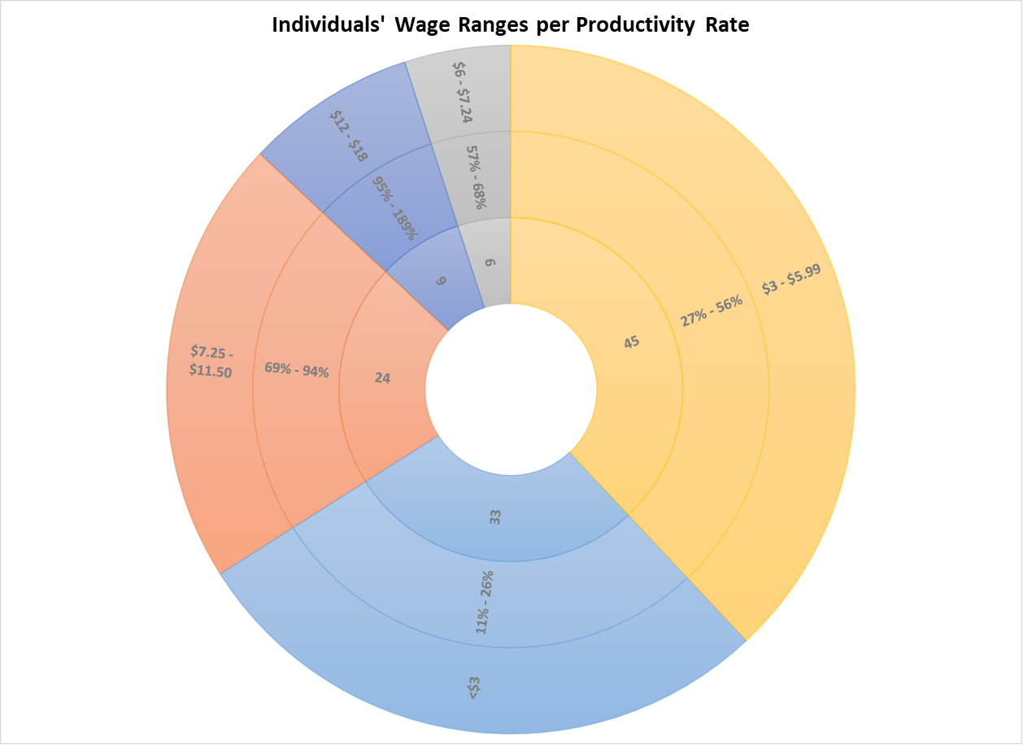

- Skills Training
  - Jobs Learned
    - 0 jobs learned 5 associates (4%)
    - 1 – 4 jobs learned 36 associates (31%)
    - 5 – 8 jobs learned 52 associates (44%)
    - 9 – 12 jobs learned 24 associates (21%)

  - Associates on the Move Program - small teams working in the community, developing professional skills and specific skill sets while building confidence as SE helps trains customers to work with neurodiverse learners.
    - SE staffs two janitorial teams for marijuana facilities 3x/week
      - Associates go through SE sponsored training to receive their own Agent ID badge issued by the State of Missouri and valid for 2 years. SE expense at $155/person.

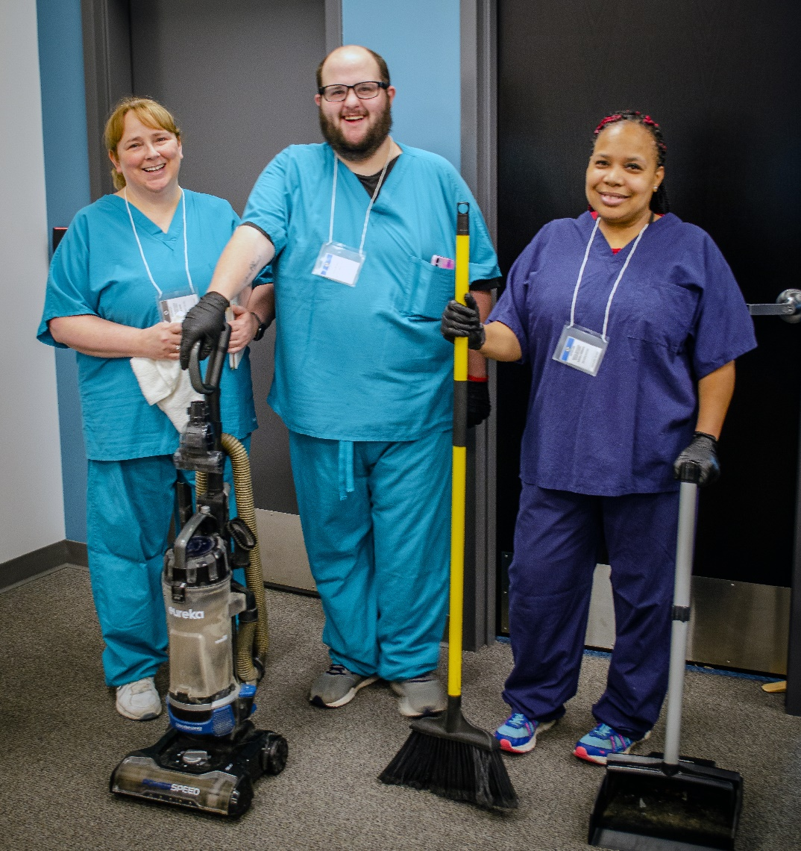
    - In-house Training for janitorial, vehicle cleaning, plant care, packaging and assembly, and light material handling are being developed and will launch in 2023.

    - Associate participants consistently report three (3) benefits of this program:
      - Learning a specific skill set
      - Work independently and confidently
      - Earn higher wages

  - Money Management – understanding currency, counting, and basics to budgeting
    - Introduced in Q2 and Q3
    - Total participants = 36 individuals

- Community Engagement/Advocacy Opportunities
  - January: Jefferson City at the State Capitol: Sheltered Workshops Products and Services Day
  - Quarterly Chamber events and Job Fairs
  - Fundraising opportunities: Chocolate sales and Picture Me Perfect Art Crawl in Brookside

- Social Activities SE hosts
  - Monthly shop wide meetings, includes awards and recognitions
    - Outstanding quality (25)
    - Outstanding Attitude (22)
    - Best teamwork (13)
    - Most improved (7)
    - Most cooperative (5)
    - Employee of the month (24)
  - End of Summer dance party with live band
  - Summer barbeque and customer appreciation day
  - Night out at The K (Royals game)
  - October Appreciation Month (every week a surprise like popcorn, business cards, pizza lunch, Grandma’s Catering, Halloween Costume contest and party)
  - Christmas party

- 2022 Annual Performance Outcomes
Effectiveness:
  - Individuals will maintain or increase AHR for the year Goal: 85% Actual: 68%
  - Individuals will participate in ATM program and
Develop skills for potential CIE Goal: 10% Actual:6%
  - Support the transition of individuals to CIE Goal: 2 ind. Actual: 7
  - Individuals have documented participation in acquiring (350%)
At least two new skills Goal: 90% Actual: 94%
  - Individuals participate in a meaningful community
Or business engagement activity Goal: 15% Actual: 14%
Experience:
  - Individuals are satisfied or highly satisfied with the
Work they are engaged in annually Goal: 90% Actual: 96.3%
  - Individuals report they are treated with dignity and
Respect Goal: 95% Actual: WIP

MISSOURI QUALITY OUTCOME #2: People Are Educated about Their Rights and Practice Strategies to Promote Their Safety and Security

Required OSHA and Safety Trainings conducted throughout the year

Drills (fire, tornado, earthquake Active shooter) Fire Extinguisher training
Colds, flu, Covid PPE Training
Slip, trips, falls Hazardous Chemicals
Blood Borne Pathogens Ladder Safety
First Aid & CPR Lock Out/Tag Out
General Safety Confined Space
Electrical Safety Seizures
Abuse & Neglect

- SE’s Safety Committee consists of our Safety Coordinator, an Associate, Production Director, and one floor supervisor and meets quarterly to discuss safety training data, reported hazards, incidents, and near misses.

Annual Safety Survey conducted with all individuals (sample survey available)

- 2022 Annual Performance Outcomes
Effectiveness
  - Required OSHA and SE Safety trainings Goal: 100% Actual: 100%
Experience
  - Individuals feel physically safe Goal: Give 3 rating out of 4
point scale Actual: Gave 3.6 rating out
Of 4-point scale
  - Individuals feel emotionally safe (have at least
One SE staff person with whom you feel safe, can
Go to feel calmed) Goal: Give 3.5 rating out of
4-point scale
Actual: Gave 3.8 rating out
Of 4-point scale

MISSOURI QUALITY OUTCOME GOAL #3: People Have Opportunities to Advocate for Themselves, Others, and Causes They Believe in, Including Personal Goals and Dreams

Individuals advocate for opportunities to learn new skills, participate on new jobs, and opportunity to attend special events. Here is a sample of some of those experiences SE has helped facilitate for the individuals we support:

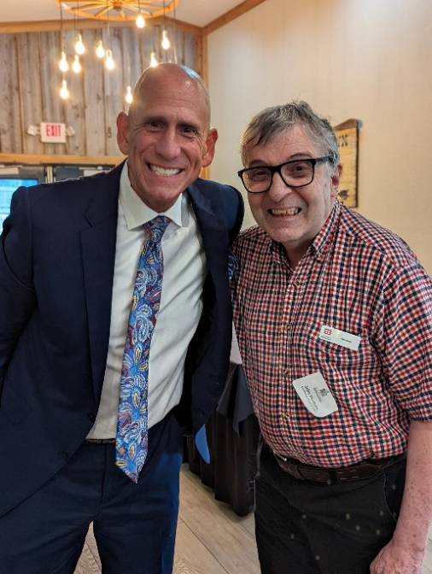John P. with Gary Lezack at a Lees Summit Chamber event. John is Gary’s biggest fan. John updates his SE co-workers every day on the weather and critical events he learns from Gary Lezack’s nightly news reports.

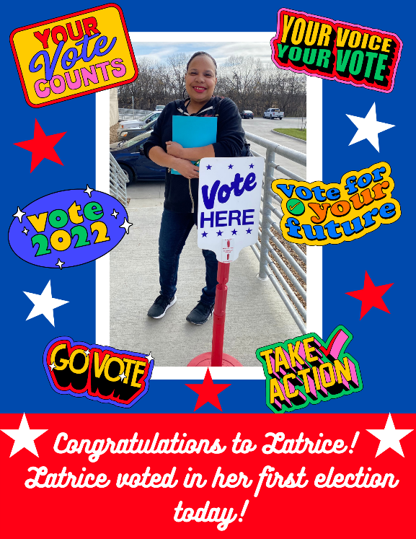 Once Latrice W. shared with SE staff how much she wanted to vote in the 2022 mid-term elections, SE staff helped her register to vote, explained the voting process to her, reviewed a sample ballot, walked her through a mock polling place, prepared her for what to expect and how to use the ADA machine, and provided transportation to and from her polling place when no transportation was available for her on election day.

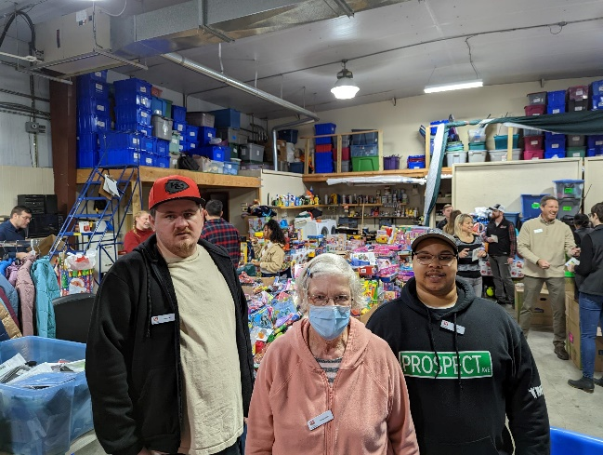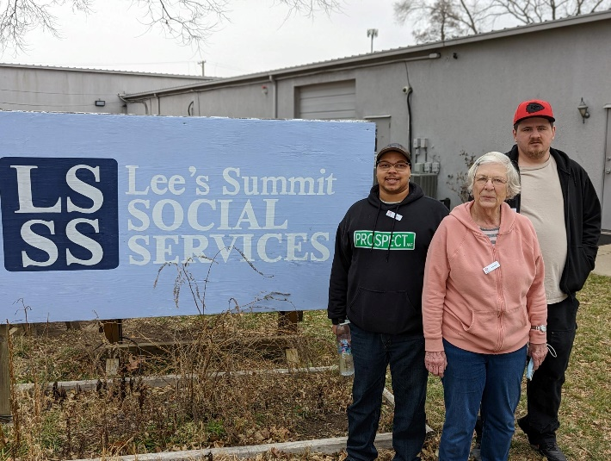
SE staff supported three individuals by transporting and working alongside them at the Lee’s Summit Social Services day helping sort and organize items for community needs. Each individual had unique gifts and excelled in the areas they participated in. One individual was particularly good at proactively sorting and organizing items independently. This has led to SE helping to develop a plan for him to cultivate this skill and apply it in broader opportunities.

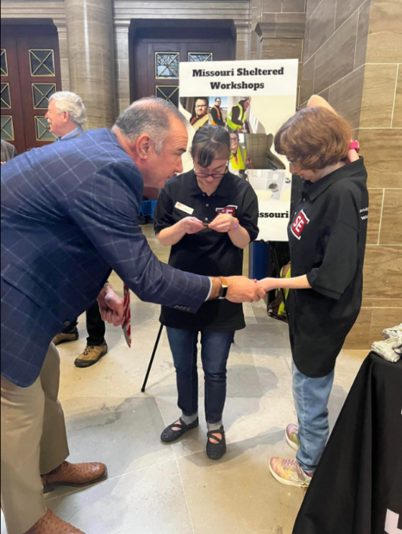Two associates represented SE at The Capitol Rotunda in Jefferson City on Sheltered Workshop Products and Services Day. Lt. Governor Mike Kehoe was particularly impressed by the products on display in the SE exhibit booth that Caitlyn and Laura produced. Here, he is giving them the official coin of his office as a keepsake in recognition of the contributions they make every day to Missouri’s economy.

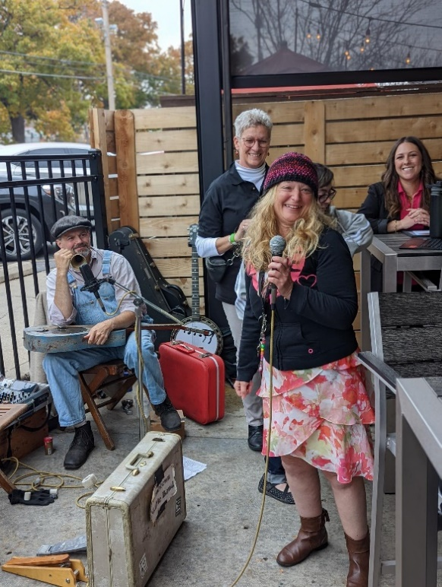 Elizabeth W. thanked the community of Brookside for attending SE’s first annual Picture Me Perfect Art Crawl in partnership with Special Olympics. She had several art pieces on display, all of which sold at auction. As an artist, Elizabeth had an opportunity to explain what motivates her to create.

- 2022 Performance Outcomes
Effectiveness
  - Individuals participate in People First KC
Chapter facilitated by SE staff Goal: 15% Actual: 7%
Experience
  - Individuals feel supported in attaining/or
Meeting their goal and/or interest Goal: 75% Actual: 96.3%

